MEDICAL COLLEGE BARODA, VADODARA
SSG HOSPITAL CAMPUS, ANANDPURA-390001
Advertisement for Recruitment of posts in VRDL, DHR-ICMR Scheme
Department of Microbiology, Medical College Baroda invites application from the interested candidates for the post of Scientist B (Medical), Research Assistant, Data Entry Operator purely on contractual basis. Please visit www.medicalcollegebaroda.edu.in for application, Project details & eligibility Criteria. Applications are to be submitted at Department of Microbiology, Medical College Baroda, Vadodara.

Last Date of Submission of Application: 27/02/2025
Sd/-
Dean
Medical College Baroda,
Vadodara

Advertisement for various posts on contractual basis under the Viral Research and Diagnostic Laboratory, DHR-ICMR Scheme at Medical College Baroda, Vadodara

Applications are invited from eligible candidates to be appointed to work on contractual basis under the “Viral Research and Diagnostic Laboratory, DHR-ICMR Scheme” in the Department of Microbiology, Medical College Baroda, Vadodara. Applications should be submitted in the format attached with this advertisement. Applications should be submitted by hand or by post/courier. Incomplete applications will not be accepted. Application should be accompanied by one (01) photocopy of all essential documents of education qualification & experience certificate(s). Candidate should bring all original documents during interview. The details of post are as below:

Sr. No. | Designation | No. of Post | Emoluments in Rs. | Qualification/ Age limit | Desirable
1 | Scientist B (Medical) | 01 | As per Annexure-I | MBBS/BDS/B.V.Sc. &AH recognized by MCI /DCI/VCI respectively or BDS/B. V.Sc degree with one year experience  Age limit: up to 35 years (relaxable in accordance to GOI instructions). | - MD in the related subject from a recognized university for candidates with first class relevant degree.  - Additional Post doctoral research/training experience in relevant subjects in recognized institute(s).  - Knowledge of Computer Applications or Business Intelligence tools/Data Management  - Two years R&D/Teaching experience in relevant subject after obtaining essential qualification.  NOTES:  - MD or M.V.Sc degree in relevant subjects shall be treated equivalent to three years experience respectively.  - Candidates with MD /MDS /M.V. Sc degree will be preferred for engagement.
2 | Research Assistant | 01 | As per Annexure-I | M.Sc. in Medical Microbiology/  Microbiology/Biotechnology  Age limit: up to 35 years (relaxable in accordance to GOI instructions). | Preference will be given to candidate having experience in research work, knowledge of computer application/data management.
3 | Data Entry Operator | 01 | As per Annexure-I | Graduate with Knowledge of data entry work.  Age limit: up to 35 years (relaxable in accordance to GOI instructions). | - Knowledge of Computer Applications /Data Management  - Experience in Data entry from recognized institute will preferred

Nature of Employment: Contractual
Duration of employment: 11 month’s period, extendable depending on the candidate’s performance and budget grant from the funding agency.

Job Location: Department of Microbiology, Medical College Baroda, Vadodara

Selection procedure

The applications received will be scrutinized by the selection committee. Recruitments will be made through by Interview. Written exams will be conducted if needed.
Last date for receiving the application: 27/02/2025

Date and time of Walk in Interview:
This will be communicated through MCB website/E-mail.

APPLICATION FORM FOR THE POST OF.......................................................... ON CONTRACT BASIS UNDER VIRAL RESEARCH AND DIAGNOSTIC LABORATORY, DHR-ICMR SCHEME, MEDICAL COLLEGE BARODA, VADODARA

Name of the post applied for:
Affix Passport Size self- attested color photograph here.
--

- Full Name of applicant in block letters:-

- Father I Husband's Name in block letters:-

- Postal Address:

State :- Pin:-

Contact Number (Mobile):

- E-mail ID:-
- Permanent Address:

State:-

- Date of Birth: DD / MM / YYYY Age: years months ( with documented evidence)
- Gender:- Male/ Female
- Knowledge of computer: CCC/CCC+ Yes/No
- Educational Qualifications:-
Name of the Examination | Subject / Discipline/ Speciality | University/ Institute College | Year of passing Final Examination | Marks Obtained / out of | Percentage | Attempt

- Work Experience if any:-

Sr. No | Name of the Institute | Name of Post | Period | Nature of Work
- Publications if any: Attach annexure
- Aadhar card number.(attach copy)

I solemnly affirm that the information furnished above is true and correct in all respects to the best of my knowledge. I have not concealed any information. I undertake that any information furnished herein if found to be incorrect or false, then I shall be liable for action as per rules in force.

Date:

Place: Candidate Name & Signature:

Enclosures:
Graduation certificate | Yes/No
Post graduation certificate | Yes/No
Experience certificates | Yes/No
CCC/CCC+ certificate | Yes/No
Adhar card photocopy | Yes/No

SCIENTIST B (MEDICAL)

ESSENTIAL QUALIFICATIONS:

MBBS/BDS/B.V.Sc. &AH recognized by MCI /DCI/VCI respectively.

Or
BDS/B. V.Sc degree with one year experience.

DESIRABLE QUALIFICATIONS:

- MD in the related subject from a recognized university for candidates with first class relevant degree.
- Additional Post doctoral research/training experience in relevant subjects in recognized institute(s).
- Knowledge of Computer Applications or Business Intelligence tools/Data Management
- Two years R&D/Teaching experience in relevant subject after obtaining essential qualification.

NOTES:

- MD or M.V.Sc degree in relevant subjects shall be treated equivalent to three years experience respectively.
- Candidates with MD /MDS /M.V. Sc degree will be preferred for engagement.

ESSENTIAL QUALIFICATIONS FOR RESEARCH ASSISTANT: Postgraduate degree
In relevant subject.
ESSENTIAL QUALIFICATIONS FOR DATA ENTRY OPERATOR: Graduate with
Knowledge of data entry work.
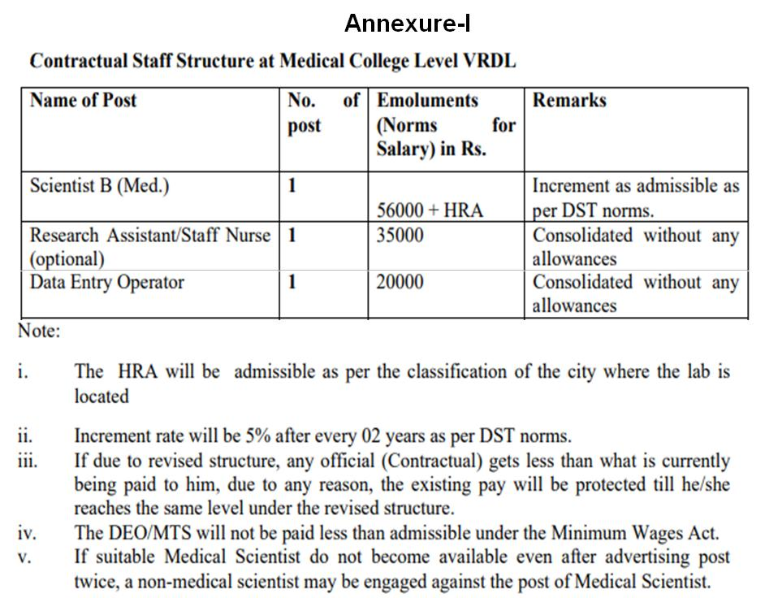

Terms &Conditions:

- Candidate have to mention post name on the envelope i.e. "Application for the post of Scientist B (Med.)/ Research Assistant/ Data Entry Operator’’ under Viral Research and Diagnostic Laboratory, DHR-ICMR Scheme.
- Application form addressed to The Head of Microbiology Department, Medical College Baroda (As per the prescribed Performa) along with self attested copies of certificates of educational qualifications, research publications and experience certificate, identity proof, and two photographs is to be submitted at the HOD’s office of Microbiology department- inward section, Medical College Baroda, Vadodara. Applications received after the last date will not be considered.
- It is the sole responsibility of the candidate to see to it that his/her application has reached at Department of Microbiology, Medical College Baroda, Vadodara. Institute is not responsible for any postal delay.
- Canvassing in anyway will lead to disqualification of the concerned candidate.
- Candidate should possess required educational qualifications and/ or experience required for the post.
- The Head of the department and the Dean will review the work of candidates appointed on the contract basis. If the review is unsatisfactory, the Dean reserves the right to terminate the appointment of a candidate without any prior notice.
- Appointed candidate has to work full time under control of the Head, Department of Microbiology and the Dean, Medical College Baroda, Vadodara. The advertised posts are under the scheme for control of outbreaks and epidemic and hence the candidate may have to work in the affected areas in the vicinity as and when required during an epidemic.
- The appointment will be purely on the contractual basis. The candidate has no right to claim for the regular appointment. Selected candidate will not be eligible for any benefits of the permanent employees or any teaching experience.
- The selected candidates for the post have to submit an undertaking regarding acceptance of rules and regulations on a Rs. 100 stamp paper duly notarized by an authorized notary. The candidate will also have to submit an undertaking on Rs. 100 stamp paper stating that he/she will not approach the Hon. Court for regularization of his/her service on the basis of the order issued for the above post or discontinuation of service.
- Appointments will be given as per rules and regulation of the concerned authority. The candidate with higher qualification and experience will be preferred.
- The candidates must possess a working knowledge on computer knowledge. Possessing CCC/CCC+ certificate is desirable.
- After scrutinizing the applications received within due date, shortlisted candidates will be called for an interview the date and timing of the interview will be notified on the institute website. If necessary, a written examination will be conducted and the candidates qualifying the written test will only be interviewed.
- TA/DA will not be paid for attending the interview. Candidates should bring all original certificates of educational qualifications, copies of research publications and experience certificate and identity proof.
- The decision of selection committee regarding appointment of candidate will be final and no representation will be entertained in this regard.
- The list of candidates found eligible will be displayed on college website. The candidates are advised to check the institute website www.medicalcollegebaroda.edu.in for the date, time and venue for the interview or written test. No separate communication will be sent to the candidates. Recruited candidates will be notified through email.
- Selection committee reserves all rights to change the selection procedure, rules & if required cancellation of the rules

Date:
Place: Signature of the Applicant

